

# Back Up and Restore the Project Center

# and Info Exchange Servers

© Copyright 2010 Newforma, Inc. All rights reserved. No part of this manual may be reproduced without the prior written permission of Newforma, Inc. The contents of this manual are subject to change without notice. Please read this entire manual carefully before beginning installation. Although the procedures described in this manual are based on the current known best practices of Newforma, Inc., these procedures may not work for you in your particular computing environment. Newforma, Inc. makes no warranty of any kind regarding the information contained in this manual, including but not limited to implied warranties of merchantability or fitness for a particular purpose. Newforma, Inc. assumes no liability to any party for any damages caused by the information in this manual or by errors or omissions in that information. If you have questions about the information in this manual or about installation procedures, please contact Newforma, Inc. (<http://www.newforma.com>). Newforma is a trademark of Newforma, Inc., in the United States and in other countries. All other brands or products are trademarks or registered trademarks of their respective holders and should be treated as such.

No: 401

# Back Up and Restore the Project Center and Info Exchange Servers

This document outlines backup and restore procedures for Newforma Project Center Server and Newforma Info Exchange Server.

This document is intended for IT professionals who are familiar with administration of Microsoft Windows servers and who have a basic understanding of administering Newforma.

# Newforma Project Center Server

Before reviewing the backup and restore procedures, it may help to understand some terminology and configuration information specific to Newforma Project Center including:

* Types of Newforma data
* Types of backup files

The backup procedures cover the following backup options:

* Automatic backup
* The manual back up processes that are available and why you would choose to use them

The restore options include:

* Restoring a single project
* Restoring all Newforma data from daily backups for disaster recovery
* Sandbox recovery to restore an old project but not bring it online. This is done on a Sandbox Server disconnected from any other Newforma servers.

# Newforma Data Types

## Global Data

This data is common to all Newforma servers and is replicated between them. It is stored in MySQL in the “newformaglobal” database. Examples of global data are: Project List, Contacts, Project Teams. A group of Newforma servers configured to replicate Global Data is called a Newforma replication domain.

## Project Data

Data for a single project is owned by (pinned to) a single Newforma Project Center Server and is stored in MySQL in the “npr” database along with any other projects pinned to that server. Using Project Center Administration, this data can be copied (mirrored) to other locations like remote offices and Newforma Info Exchange.

It is important to understand that project data contains references to data in the global database such as contacts, keywords, and the project team. A project backup isn’t complete without a related global database backup.

## Registry Data

Some configuration data for a Newforma Project Center Server is stored in the Windows registry in HKEY_LOCAL_MACHINE/Software/Newforma This will be backed up to a file as part of the automatic backup.

# Backup File Types

All backup files will contain one of the following extensions:  
  
**.NGB - A zip file containing all global data common to all servers used for disaster recovery.  
.NPB - A zip file containing all project datafor one project used for recovery of a single project.  
.NRB - A zip file containing an NGB and NPB file used for recovery to a Sandbox Server or for recovery of a single project. See the section below on** Sandbox Recovery for more information.

**IMPORTANT**: **Newforma backup files never contain a copy of the project files on your file server. That data must be backed up using your standard file backup procedures.**

# Backing Up Newforma Data

## Automatic Backup

Newforma Project Center Server performs backups automatically each day. It creates a file containing the full backup of the global data. It also creates a file of project data for each project that has been modified since the last time it was backed up. Finally, it creates a .REG file for each Newforma Project Center Server containing that server’s Windows Registry settings.

To access the backup options in Newforma Project Center, select Project Center Administration, select the Servers tab, and then select the Newforma Project Center Server. The following options are available for backups:

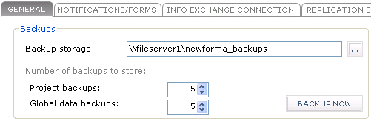

The “Backup storage” location would ideally be a DFS or UNC path (\\server\share) to a file server that the Newforma server has write access to. It is recommended that this location be backed up as part of your regular backup procedures since files are overwritten when the file count exceeds the configured values. That way the files can be restored from any system on the network.

Pointing all servers to the same folder is possible and should work with a couple of caveats:

* Newforma Project Center Servers with the same name will cause the global data backups to be overwritten. This may be a remote case since a single Windows domain does not allow systems with the same name.
* If there are multiple Newforma replication domains and duplicates of the same project on different servers, then the project data backups will be overwritten. For example, if there was SERVERA and SERVERB but they were not configured to replicate and they both had an upgraded copy of the same project then the problem would occur. For this reason it is recommended to have **a separate backup location for each Newforma domain** if there are multiple Newforma domains.

**IMPORTANT**: AS a best practice in a multi-server topology where a common backup storage location will be used, point the backup storage location for each Newforma Project Center Server to its own unique subfolder.

The “Project backups” count defines the number of backups per project that the server automatically creates and the “Global data backups” count defines the number of global backups the server creates.

The “Backup Now” button will perform a full backup of the global data and project data and store it in an NGB file and a series of NPB files just like the automatic backup. It does not update the last backup time for each project so the daily automatic backup will still backup each project that has been modified since the last backup.

Below is a screen shot of the backup directory for a server with two projects. The naming scheme for the project backup files is *Unique Id-Project Name-Date Time.npb*. The naming scheme for the global backup file is *Server Name-Date-Time.ngb.* There is an NPB file for each project and an NGB file for the global data. This shows multiple copies of each project and multiple copies of the global data. The number of copies stored is limited by the settings in the dialog shown above.

There is no distinction between files created by the automatic backup and files that use the “Backup Now” option. They are all placed in this folder and made unique using the file naming convention.

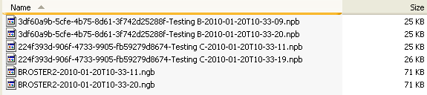

**IMPORTANT**: Depending on disk space limitations, the backup settings controlling how many files to copy may only allow Newforma to restore data for a small window of time. If larger windows are needed, more disk space, or an additional incremental backup strategy using backup software may be necessary.

**NOTES**:

* The .REG file that is created for each Newforma Project Center Server is overwritten each night. Multiple copies of this file are not maintained.
* The “Backup Now” button does not create a .REG file for the server registry settings. The .REG file is only created as part of the automatic backup.

## Manual backup

### Backup Now for disaster recovery

This can be performed by the “Backup Now” option described above. This creates backup data just like the automated backup that can be used for disaster recovery.

### Backup When Deleting a Project

When you select a project in Project Administration and select the Delete task, the system prompts to make a backup of a project. This creates an NRB file that can be used for Sandbox server recovery or single project recovery. See the topic below.

### Backup When Taking a Project Offline

When you select a project in Project Administration and select the Move Project Off-line task, the system prompts you to make a backup of a project and provide a label for where the project will be stored. The label is purely informational and is typically used to describe the backup contents and where it might be stored. This creates an NRB file that can be used for Sandbox server recovery or single project recovery. Instructions for moving a project off-line are provided in the help. See the topic below to bring a project back online.

### N4 backup

This may be desirable at certain milestones in a project in order to keep historical data around for accountability. This form of manual backup creates backup data in NRB format that can be used for Sandbox Server recovery or single project recovery. These steps are done on the Newforma Project Center Server that the project is pinned to.

1. Open a command window and navigate to the N4 directory. This is in the *<installation directory>\Newforma Project Center Server*.
2. Obtain the project GUID (globally unique identifier) for the project. There are a couple of ways to do this.

One way is to enter the following commands in the command window:

mysql --user=root --password=<root password> --host=localhost --database=newformaglobal

mysql> select id from project where project_name like '%Testing C%';

Just replace the value between the % signs with a unique part of the project name you are looking for. Then copy the results to the N4 command in the next step. See screen shot below. It will be necessary to supply the correct password for the root user. Type “quit” to get back to the Windows command prompt.

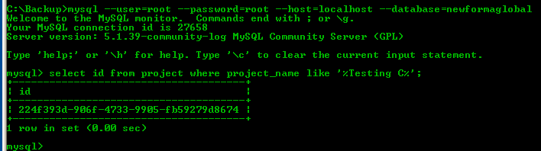

Another option to get the project GUID is to open the project in Newforma Project Center and do control-shift-I keyboard combination to get the detailed information on the project. The project GUID is listed under ‘Current Project ID’. (See screenshot below for an example)

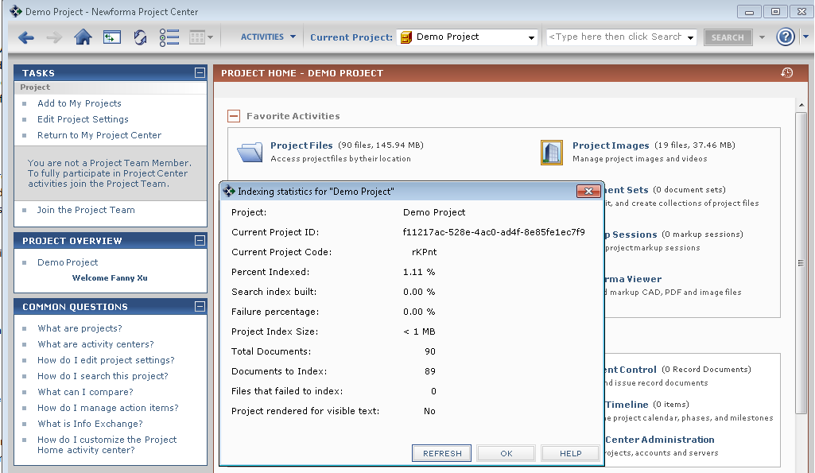

1. Run the following command:

n4 database backup -r <ProjectGuid> -l "<Backup Folder>"

ex.

n4 database backup -r 224f393d-906f-4733-9905-fb59279d8674 -l "C:\Backup"

# Restoring Data

## Single Project Recovery

The admin page allows an administrator to restore project data for a single project by selecting an NRB file or an NPB file. See topics above for how to create files of each type. If electing to use an NRB file, be aware that the global data contained in the NRB file is ignored as part of this operation as it will use the global data already in the active database. Restoring global data is outlined in the disaster recovery section below. Simply choose the restore option from the “projects” tab. If the project already exists on the server then the restore operation fails.

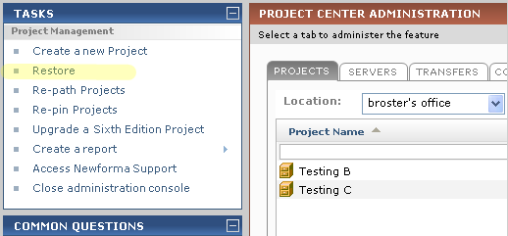

**WARNING**: Project data contains references to data in the global database such as contacts, keywords, and the project team. Restoring an old project database to a server with newer global data causes the project to inherit any changes to the referenced data since the project was backed up.

## Project Data, Global Data, Registry Data (Disaster Recovery)

In the event a Newforma Project Center Server needs to be rebuilt from the automatic daily backups, follow the steps below.

**NOTE**: To ensure proper recovery, set up the new server using the same installation directories and server name as the original server. This is necessary because the registry backup to the .REG file contains file system paths and server names. If this is not possible, then it is necessary to manually patch up references in the .REG file or skip the step for merging the .REG file. Skipping the merging of the .REG file will affect Template Styles but that can be merged in manually if necessary by editing out the other sections of the .REG file.

1. Ensure the Newforma Project Center Server is installed and operational and connected to the network where all the project files reside.
2. Shut down the Newforma Project Center Server service from the Windows management console.
3. Locate the most recent .NGB file in the backup folder where daily backups are copied.
4. Open a command window and navigate to the N4 directory. This is in the *<installation directory>\Newforma Project Center Server*.
5. Run the following command:

N4 database restore -g “<Path to NGB file>”  
  
For example:

N4 database restore -g “\\fileserver1\newforma_backups\ BROSTER2-2010-01-20T10-33-20.ngb”

1. Verify there were no errors during the restore by checking the N4 log:
   1. Go to Start->Run, then type %temp% and hit enter to open the Temp directory
   2. Open the N4 Database Restore.log file (confirm that modified time is most recent)
   3. Look for any events that could signify errors during the restoration (i.e., search for the term “error”)
2. Once the restore is complete, download the script - “touch_local_projects.sql” and copy it to a backup folder (e.g., C:\Newforma_backup ) and run the command below:

mysql --user=root --password=root --database=newformaglobal < “c:\Newforma_backup\touch_local_projects.sql”

If the script executes successfully, it will skip to a command prompt as shown below:

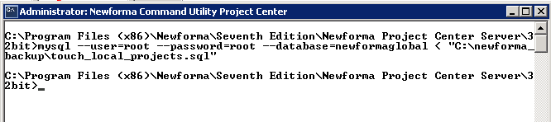

**Important**: Do not start any of the Newforma Services until the SQL script (touch_local_projects.sql) has been run otherwise data on other Project Center Servers and Info Exchange Server could be adversely affected.

1. Find the .REG file for the server and copy it to a folder on the Newforma Project Center Server.
2. Double click the .REG file to merge in the settings.
3. Start the Newforma Project Center Server service from the Windows management console.

The global data that gets restored as part of this command contains pointers to the file locations of all the last backups for each project. The N4 command will go through each project and try to load the backup file in order to restore the project data. Make sure the Windows user running the N4 command has access to locations containing the backup files.

If there are other servers in the Newforma domain then the newly restored server will resume its replication task and will receive the latest global data from the other servers in the Newforma domain.

## Restoring Old or Off-line Projects (Sandbox Recovery)

This option would be used to look at an older Newforma Project but not bring it back into the active Newforma domain. The project may have been deleted, taken offline, or is an old backup from a still active project. Using a Sandbox Server allows you to bring the project online without the risk of damaging active global or project data. The Sandbox Server needs to be a standalone server not joined or replicating to any existing Newforma domains. All the following steps take place on the Sandbox Server.

**IMPORTANT**: This server needs to be taken off of the network prior to installing Newforma software. The server will attempt to access network files and other Newforma servers once it is running and will result in modifications to production data.

1. Build up a Sandbox Server to the specifications in the Newforma requirements document.
2. Set up and install the Newforma Project Center Server and verify the installation is operational.
3. Install the Newforma Project Center client.
4. Shut down all of the Newforma services from the Windows management console in the order shown below (Filtering, Indexing, Project Center, Text).

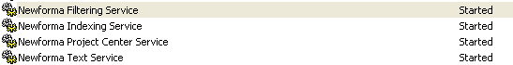

1. Locate an existing **.NRB** file and copy it to a folder on the Sandbox Server.
2. Open a command window and navigate to the N4 directory. This is in the *<installation directory>\Newforma Project Center Server*.
3. Run the following command:

N4 database restore -r “<NRB folder>/<NRB file>.NRB”

For example:

N4 database restore -r “C:\Restore\Test -2010-01-01T12-00-00.nrb”

1. Start all of the Newforma services from the Windows management console in the reverse order shown above (Text, Project Center, Indexing, Filtering).
2. Launch Newforma Project Center and the project in the .NRB will be available.

There are a couple of key limitations of a project that has been restored to Sandbox Server:

* The project files that are referenced by the project will not be available unless they are restored as well. If these files are restored to a different location than their original location then the project will need to have folder references patched using the “re-path” task from Project Administration Projects tab in Newforma Project Center after the project is brought back online.
* Info Exchange will not be available for this project.

## Manually Creating NRB File for Sandbox Recovery

**WARNING**: It is very important for the NGB and NPB file to be properly matched. Follow the guidelines below closely. If they are not properly matched then projects may not appear and other problems can occur. Recreate the NRB with the correct files if any problems are noticed.

Since an NRB file is simply a zip of an NGB file and an NPB file it is easy to create one manually. This may be necessary if an administrator needs to look at some project data as of a specific date. Use the following steps to create the NRB:

1. Locate the NGB file for the date in question
2. Locate the NPB file for the date in question. Since NPB files are only created when the project changes it may be necessary to go back some amount of time to find the last created NPB file.
3. Copy the two files to a temp folder if they are not already in the same folder.
4. Select both files in Windows Explorer and choose the task to create a compressed folder

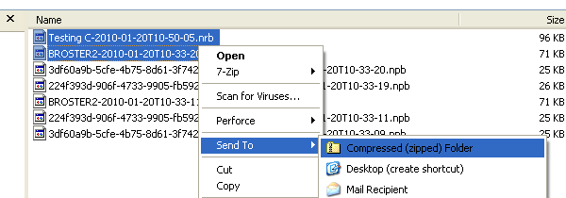

1. Name the resulting file with a .NRB extension
2. Follow the steps above for Sandbox recovery.

# Newforma Info Exchange Server

# IMPORTANT

Newforma Project Center Server manages synchronization of project data to Info Exchange automatically so we do not recommend backing up the MySQL database in 7th edition. Restoring project data to Info Exchange that is not in sync with the data on the Project Center Server will force the project to be re-synchronized in full, negating any recovery time gains being sought by a backup strategy.

However, there is other data on Info Exchange that does need to be backed up such as File Transfers and the web site SSL certificate. These steps are outlined below.

# Backup

## Backing Up File Transfers

The file transfer ZIP files are in a Transfers directory in the installation directory. Assuming the installation directory was C:\Newforma Info Exchange, the file transfers would be stored in C:\Newforma Info Exchange\Transfers.  
  
The files in this directory may at times be open by Info Exchange so the backup software will need to be able to handle open files properly.

Ideally these files would be backed up daily by software that supports incremental backups. That will greatly reduce the amount of space these files consume in the backup archive.

## Backing Up the Web Site Certificate

Backing up the web site certificate only needs to be done once and the file placed in a safe location.

### Instructions for IIS6

1. Open Internet Information Services Manager
2. Open the Properties dialog for the Info Exchange web site and go to the Directory Security tab
3. Click on the Server Certificate button
4. Click next on the wizard and choose to “Export the current certificate to a .pfx file”
5. Assign a password and complete the wizard

### Instructions for IIS7

1. Open the Internet Information Services Manager
2. In Features View click on Server Certificates
3. Select the certificate to export
4. Use the “Export…” action at the right of the screen
5. Enter the path to the .pfx file and the password
6. Click OK to finish

# Restore

Depending on the nature of the problem that required a restore, there may be a need to reinstall Info Exchange and/or MySQL. The steps below assume that Info Exchange and MySQL have been installed. Please see the deployment documentation for information on how to setup MySQL and Info Exchange.

## Restoring File Transfers

Restore the file transfer files (ZIP) to their proper directory. This is C:\Newforma Info Exchange\Transfers from the backup example above.

## Restore the web site Certificate

### Instructions for IIS6

1. Open Internet Information Services Manager
2. Open the Properties dialog for the Info Exchange web site and go to the Directory Security tab
3. Click on the Server Certificate button
4. Choose “Import a certificate from a .pfx file” and click Next
5. Select the .pfx file and click Next
6. Enter the password and click Next
7. Select 443 for the SSL port and click Next
8. Click Next to finish the process

### Instructions for IIS7

1. Open the Internet Information Services Manager
2. In Features View click on Server Certificates
3. Use the “Import…” action at the right of the screen
4. Enter the path to the .pfx file and the password
5. Click OK to finish
6. Back in Internet Information Services Manager in Features View select the Info Exchange web site and select the “Bindings…” action on the right of the screen
7. Select the https binding from the list and click Edit
8. Make sure the restored certificate is selected in the SSL certificate drop down
9. Hit OK to finish

## Forcing Synchronize with Info Exchange

After completing the restore of the File Transfers and Web Site Certificate, projects need to be forced to synchronize with Info Exchange. This command will need to be run on each Newforma Project Center Server that is connected to Info Exchange.

1. Open a command window and navigate to the N4 directory. This is in the *<installation directory>\Newforma Project Center Server*.
2. Run the following command:  
     
   N4 npcs syncprojects -s <source server name> -t <target server DNS name> -n <target server type>  
     
   For example:  
     
   n4 npcs syncprojects -s NPCS01 -t infoexchange.newforma.com -n NIX  
     
   Projects that have been modified recently will have priority. Older project will be synchronized to Info Exchange at a lower priority. Depending on the size of the project it can take anywhere from a few seconds to several minutes to synchronize to Info Exchange.